PORTFOLIO WEBSITE
Micro Project-1 Report
Submitted for the partial fulfillment of the degree of
Bachelor of Technology
in
ARTIFICIAL INELLIGENCE & MACHINE LEARNING
Submitted By
PRASHANT SHARMA, ANSH CHIPPNE
BTAM25O1051, BTAM25O1012
UNDER THE SUPERVISION OF
DR. VIBHA TIWARI
ASSISTANT PROFESSOR
Centre for Artificial Intelligence

December 2025
Declaration
I hereby declare that the work entitled Portfolio Website is my work, conducted under the supervision of Dr. Vibha Tiwari , Assistant Professor, during the session July-December 2025. The report submitted by me is a record of bona fide work carried out by me.
I further declare that the work reported in this report has not been submitted and will not be submitted, either in part or in full, for the award of any other degree or diploma in this institute or any other institute or university.
--------------------------------
Ansh Chippne, Prashant Sharma
BTAM25O1012, BTAM25O1051
Date:
Place: Gwalior

This is to certify that the above statement made by the candidates is correct to the best of my knowledge and belief.

Supervised By:

______________
Dr. Vibha Tiwari
Assistant Professor
Centre for Artificial Intelligence
MITS Deemed University, Gwalior

Plagiarism Check Certificate
This is to certify that I/we, a student of B.Tech. in Artificial intelligence & Machine Learning, have checked my complete report entitled Portfolio website for similarity/plagiarism using the “Turnitin” software available in the institute.
This is to certify that the similarity in my report is found to be …… which is within the specified limit (20%) and AI writing is…….which is limited to 50 %.
The full plagiarism report, along with the summary, is enclosed.

--------------------------------
Ansh Chippne, Prashant Sharma
BTAM25O1012, BTAM25O1051

Checked & Approved By:

--------------------------------
Dr. Vibha Tiwari
Assistant Professor
Centre for Artificial Intelligence
MITS Deemed University, Gwalior

Abstract
Background :- The project named “ PORTFOLIO WEBSITE ” focuses on front end styling. While html is used to provide the structure of the website , this project uses css to provide styling and animations.
Method :- we made the design with focus on smooth user interaction it uses @keyframes to animate elements upon loading, we also built an fixed navigation bar that stayes fixed at the to of the screen, so that user can find their target without much scrolling.
Result :- the result is a single page website that looks like a modern app than an document. When you open the page elements slide and pop into place.
Conclusion :- The teacher profile we created looks colorful, organized, and easy to read. This project also made me more confident in using animations and layout techniques. Overall, it was a good learning experience and gave me a clear idea of how professional profile pages are designed.

Acknowledgement
I would like to express our greatest appreciation to all the individuals who have helped and supported us throughout this lab file. I am thankful to the whole Centre for Artificial Intelligence department for their ongoing support during the experiments, from initial advice and provision of contact in the first stages, through ongoing advice and encouragement, which led to the final report of this lab file. I humbly thank Dr. R. R. Singh, Head, Centre for Artificial Intelligence, for his continued support during the course of this engagement, which eased the process and formalities involved. I am sincerely thankful to my faculty mentors. I am grateful for the guidance of Dr. Vibha Tiwari, Assistant Professor, Centre of Artificial Intelligence, for his continued support and guidance throughout the project. I am also very thankful to the faculty and staff of the department.

-----------------------------
Ansh Chippne, Prashant Sharma
BTAM25O1012, BTAM25O1051

Content
Table of Contents
Declaration by the Candidate i
Plagiarism Check Certificate ii
Abstract iii
Acknowledgement iv
Content v
Acronyms vi
Nomenclature vii
List of Figures viii
List of Tables ix
Project 1
References 8
Turnitin Plagiarism Report 9
Acronyms
- HTML = Hyper Text Markup Language.
- CSS = Cascading Style Sheets.

List of Figures
- This is Profile Page
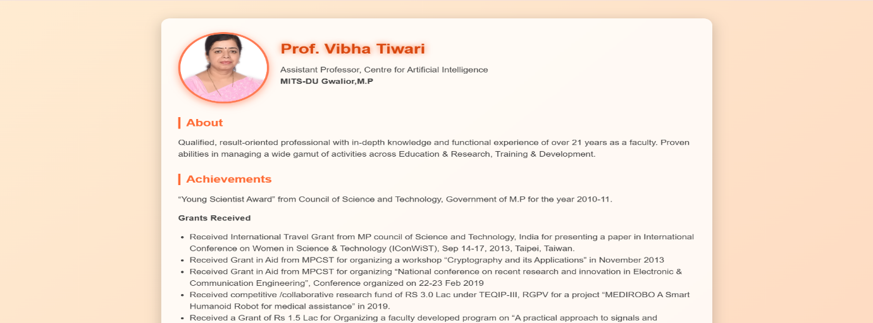
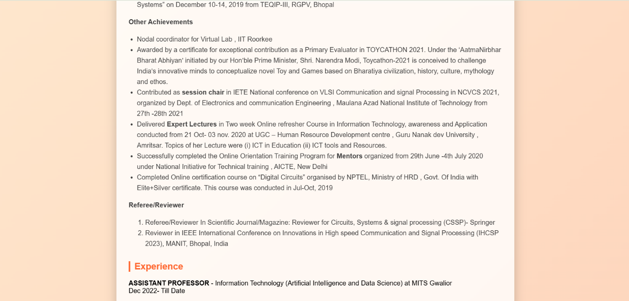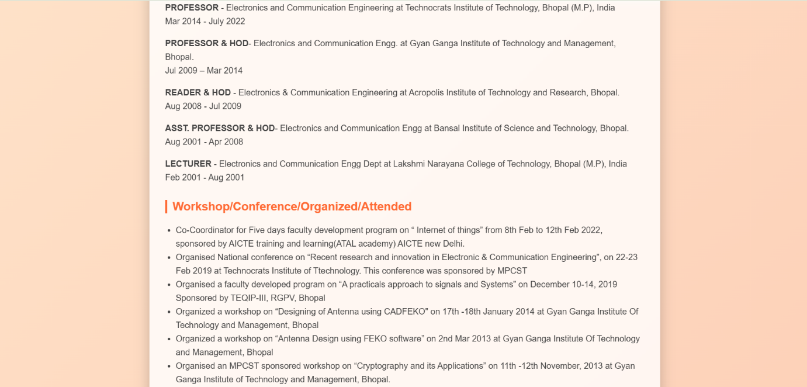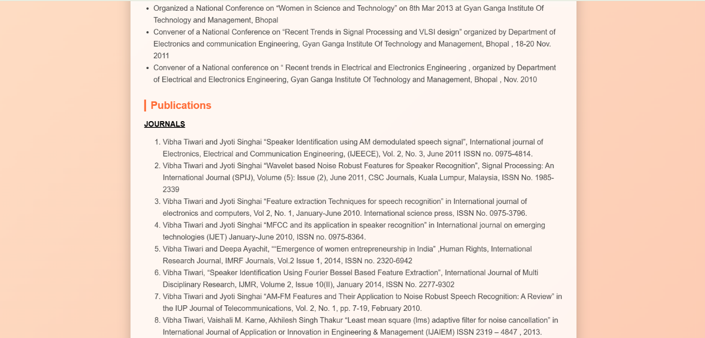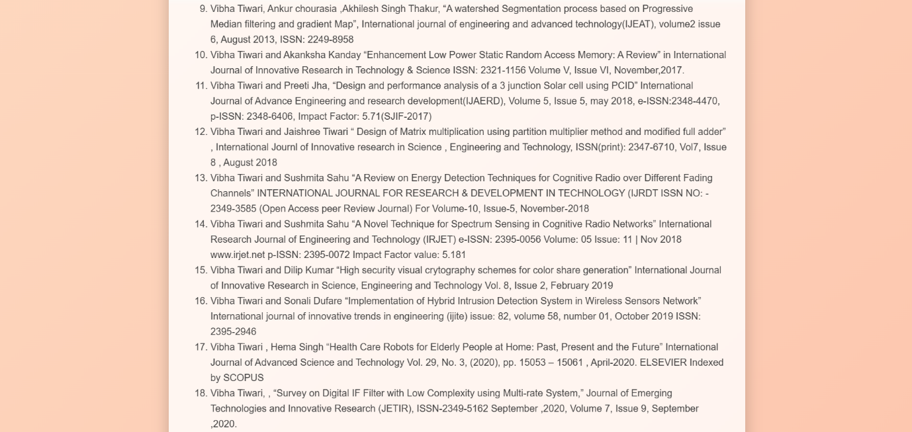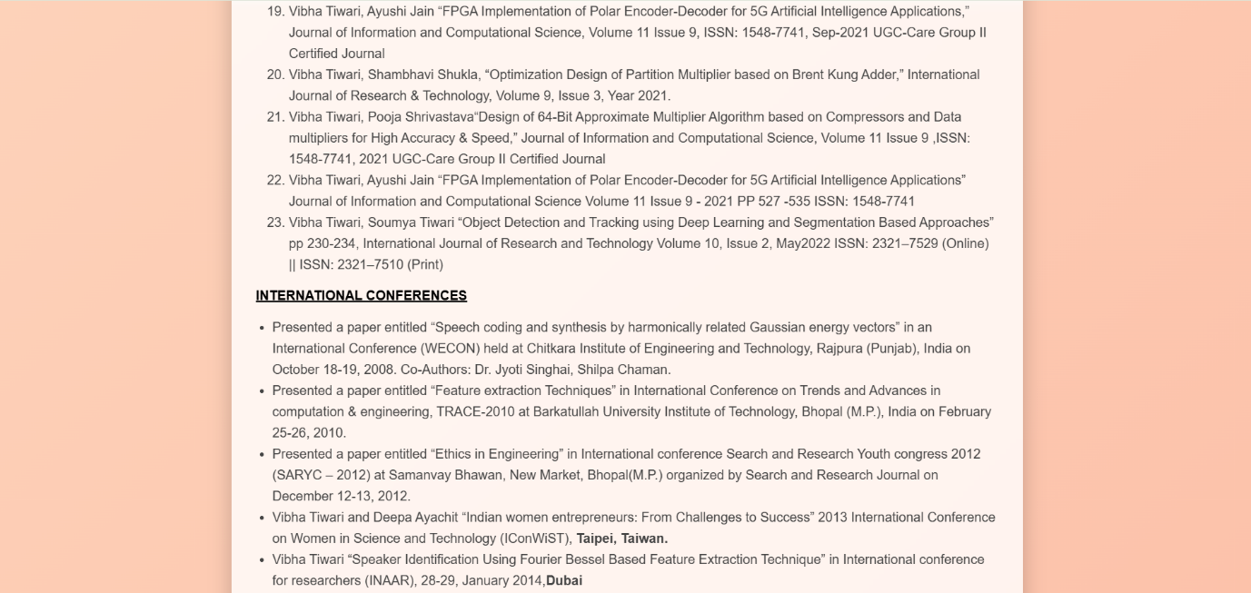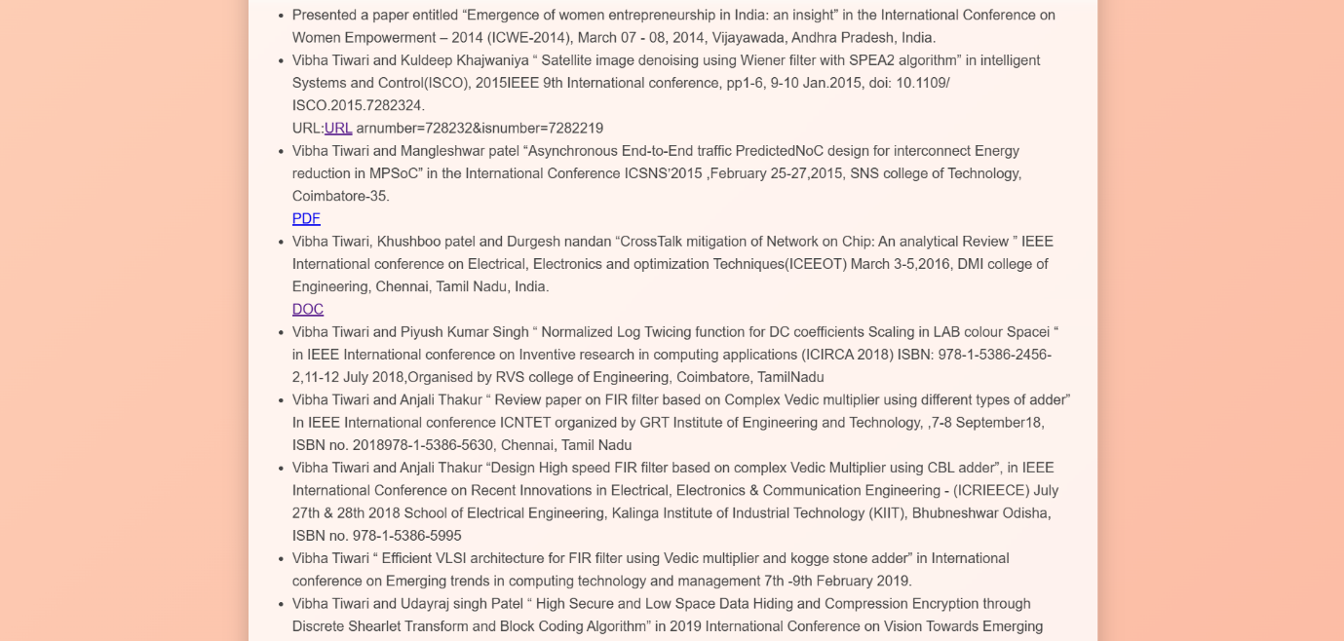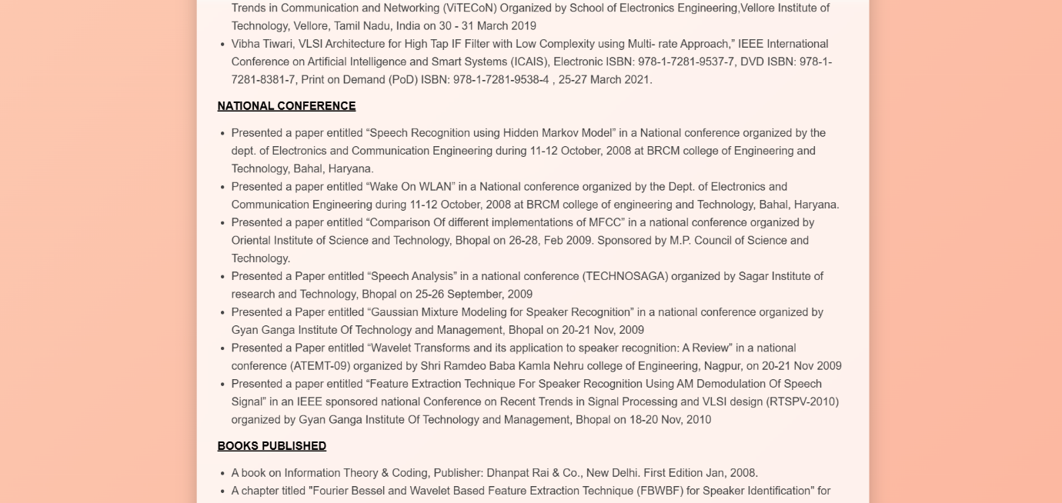

Source Code :-
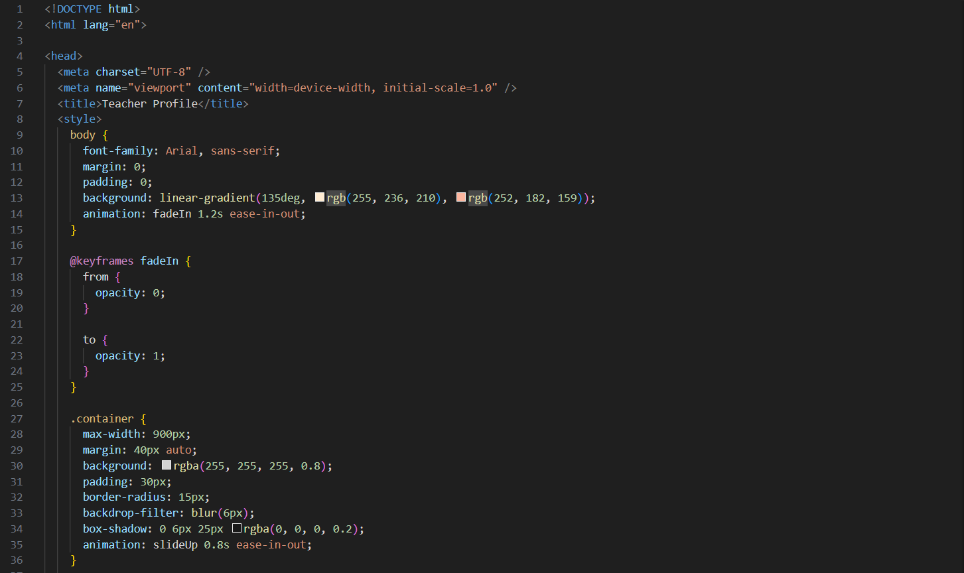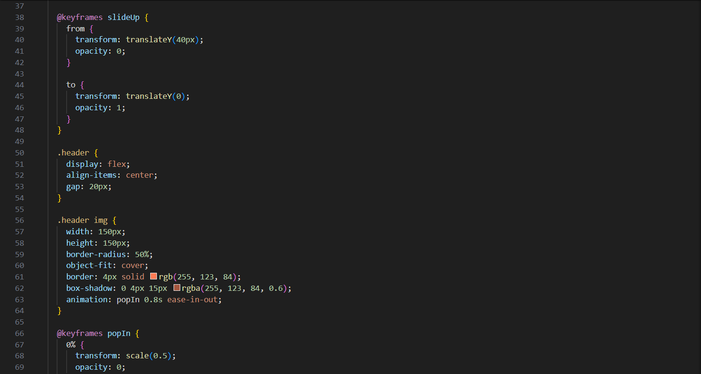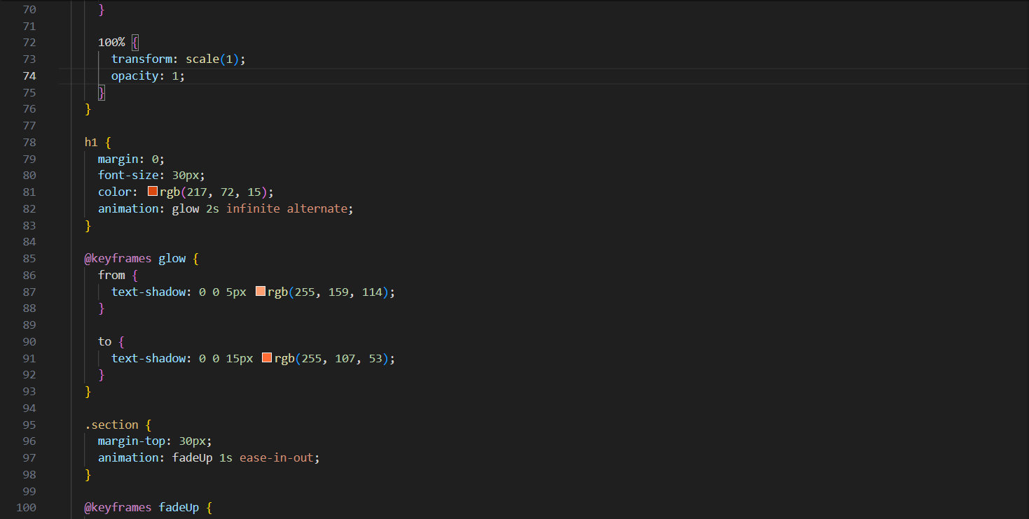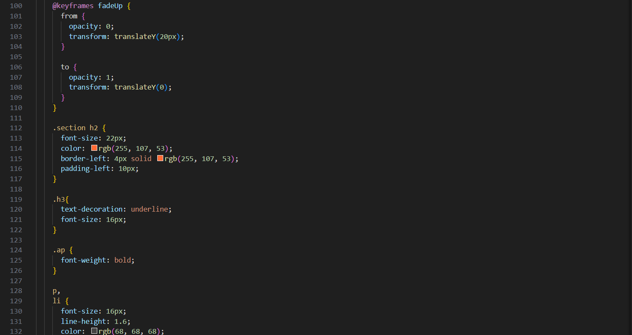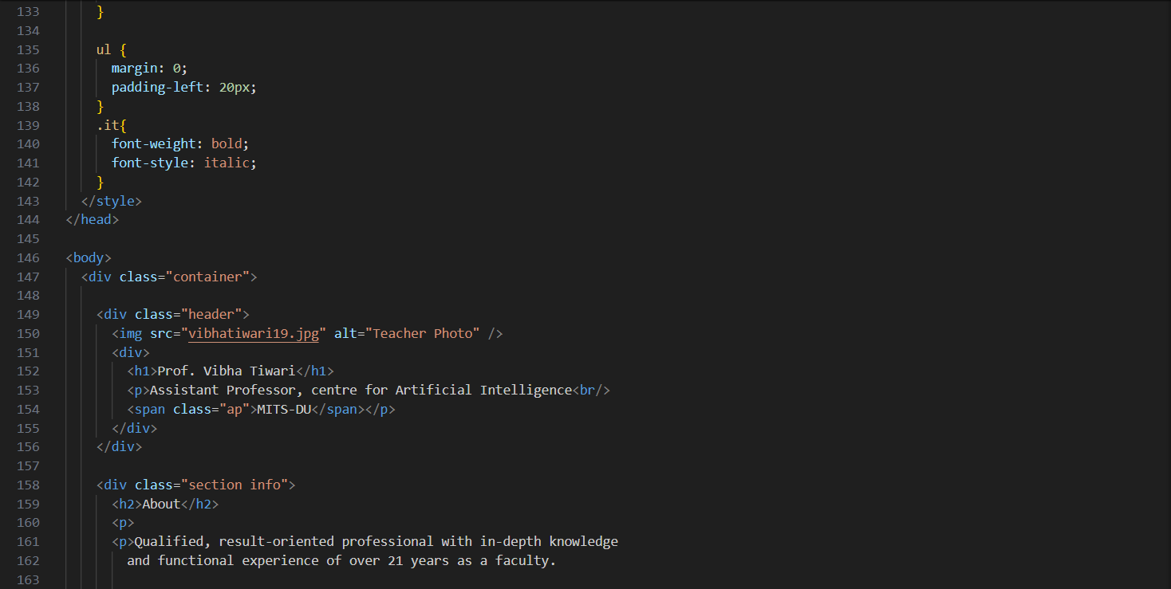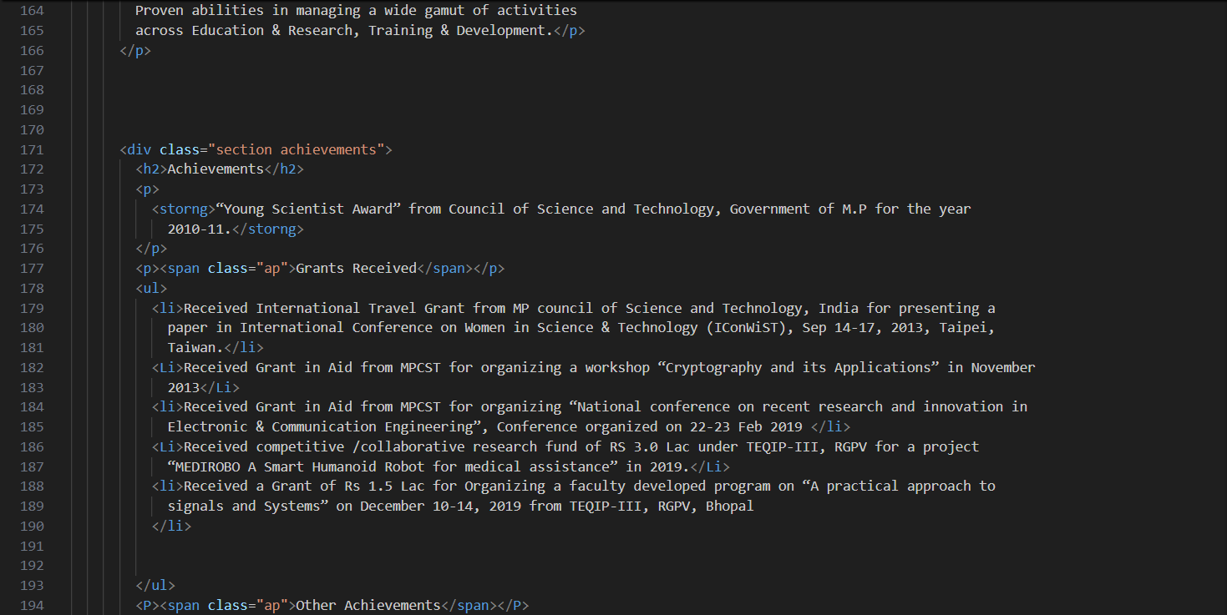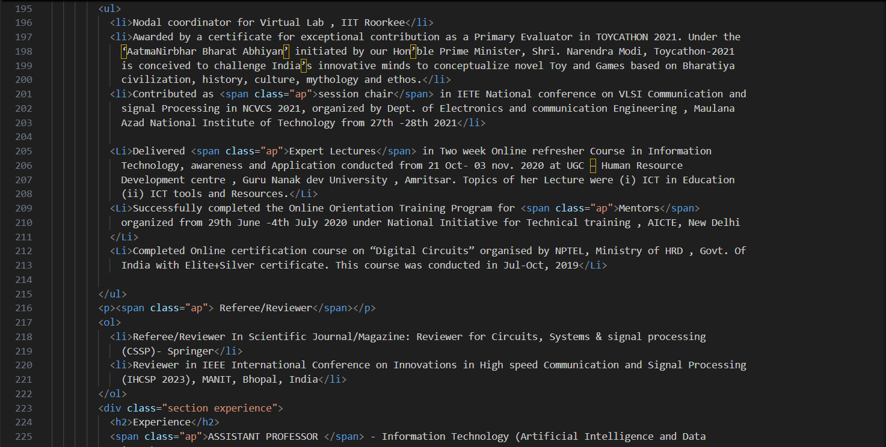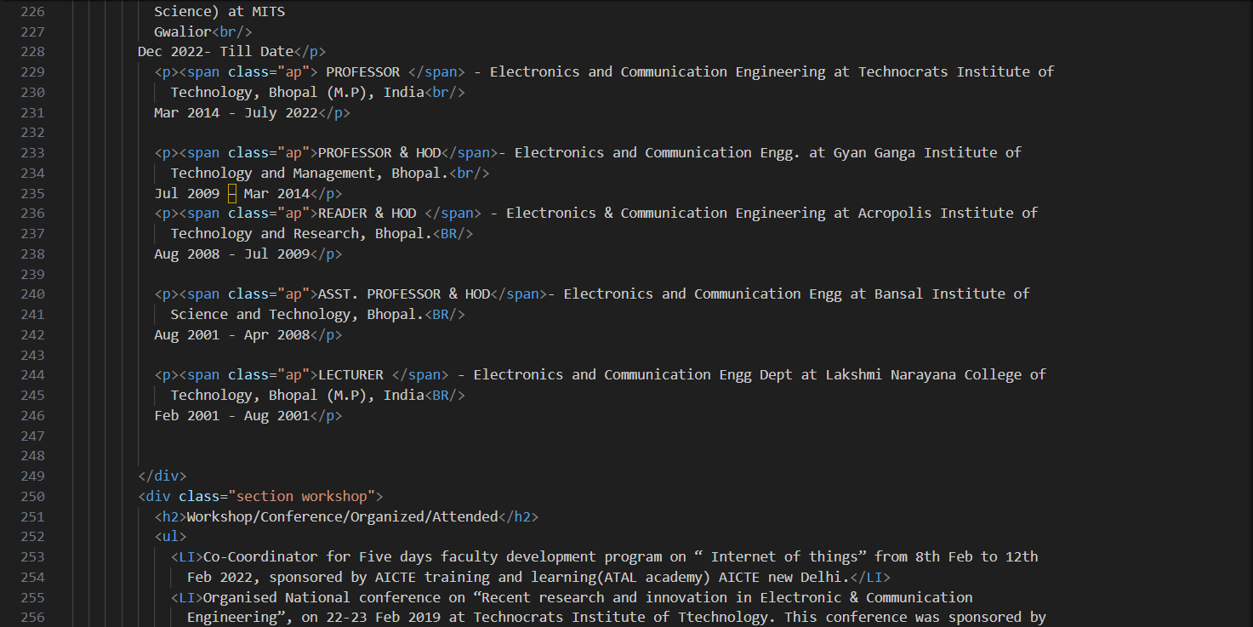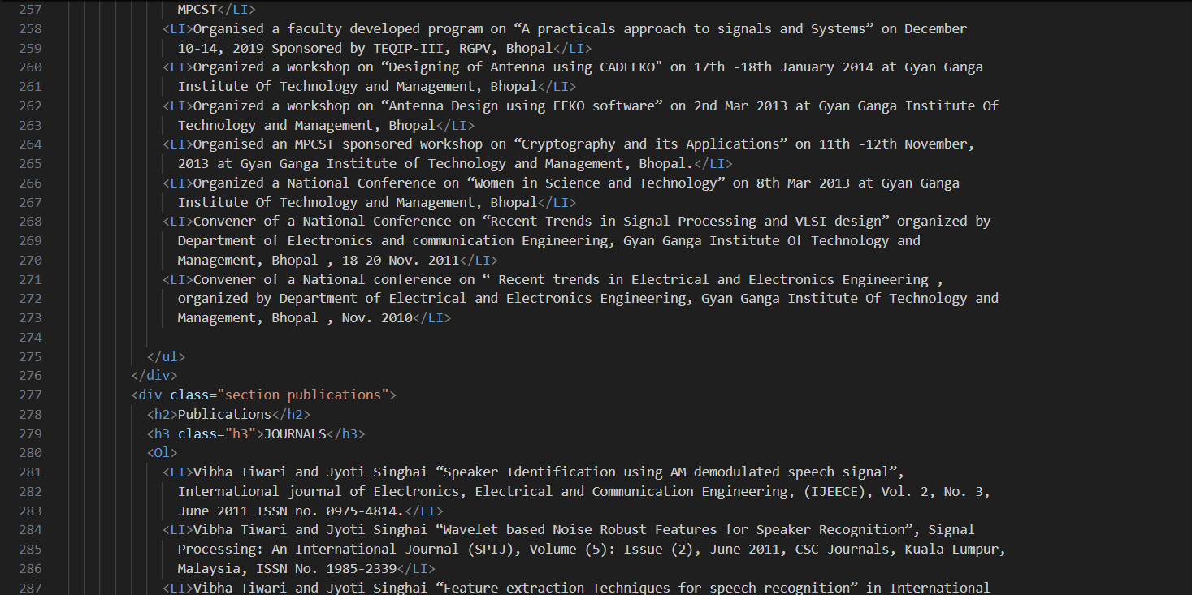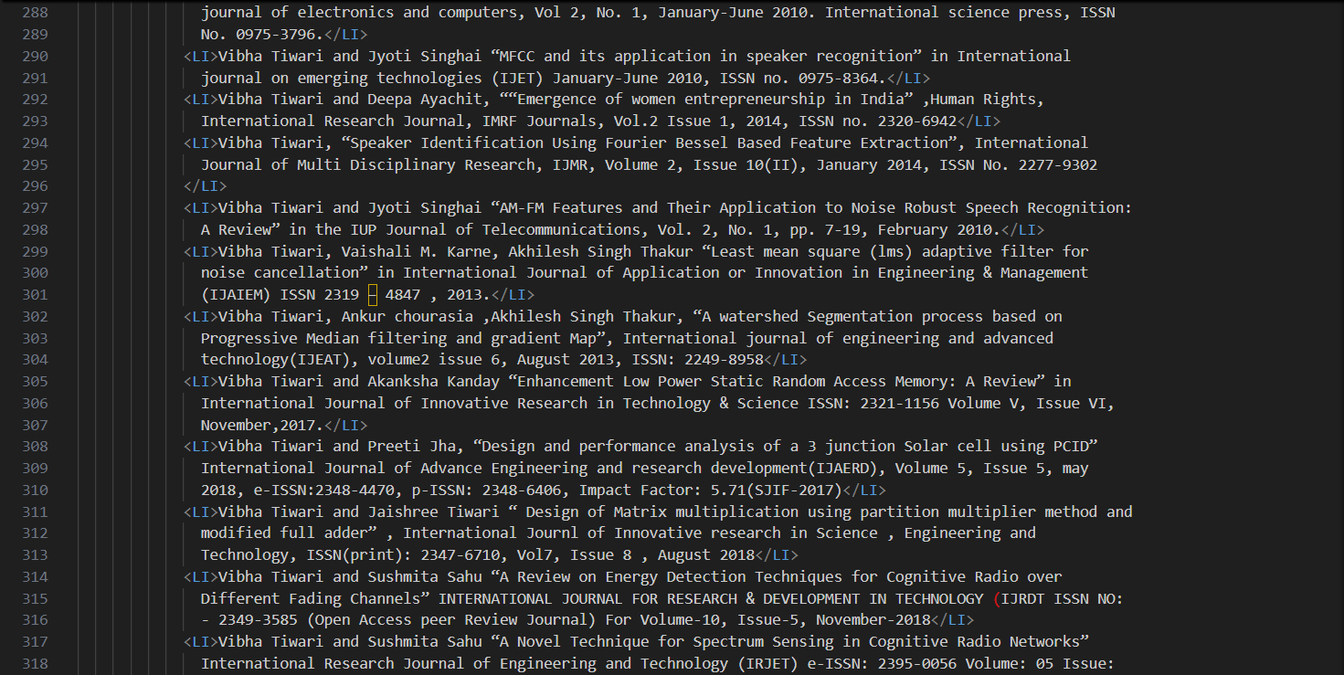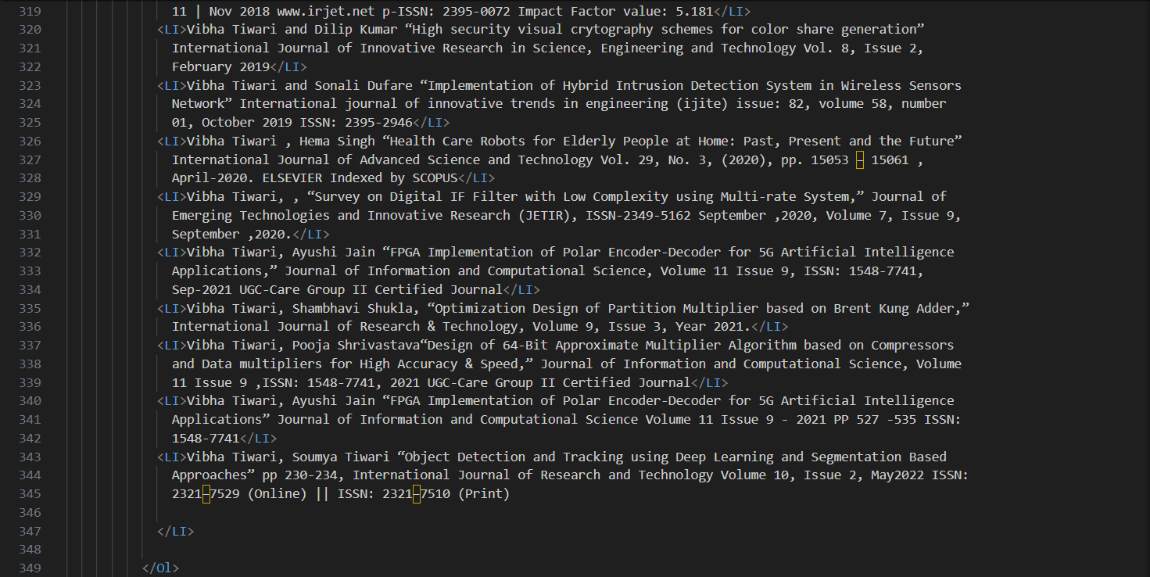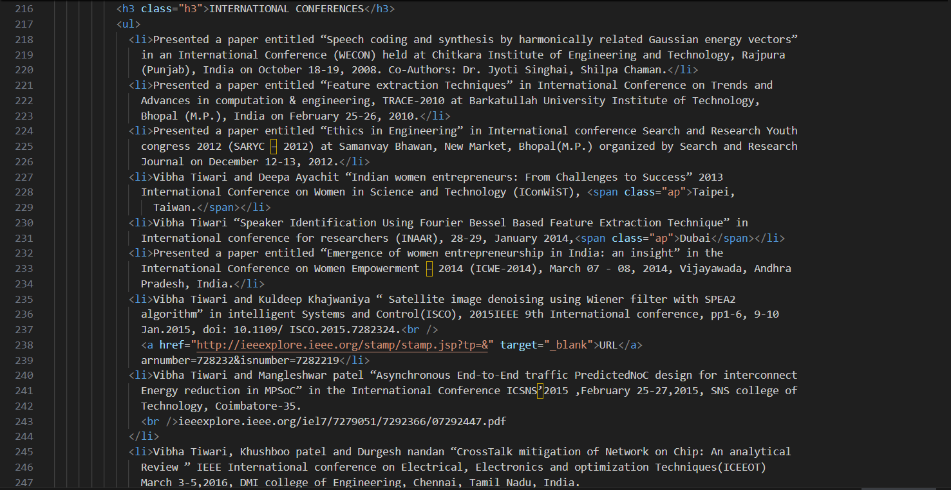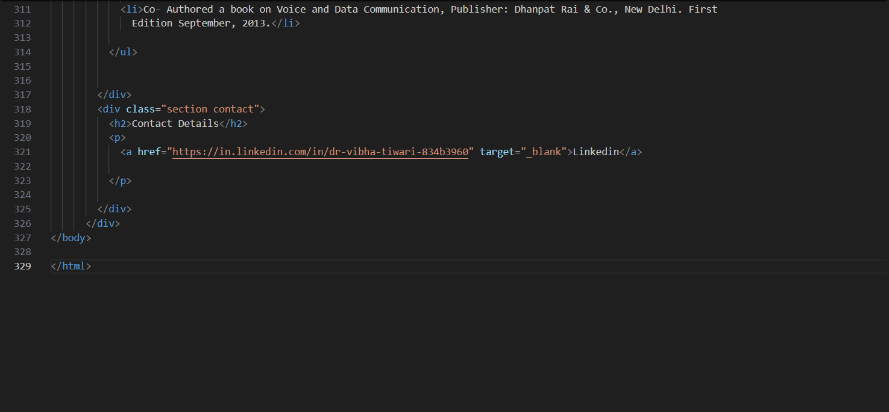

Chapter 1: Introduction

This project is called the Profile Page Creation we built a digital page for someone’s info. It is like a personal website but focused on showing off who you are and what you can do. This project is our attempt modernize the traditional acadmic resume. It replaces the past CVs that were just pieces of paper or plain digital files with black text on a white background but in this project we focuses on user experience , beautiful interface with smooth colors , nice fonts and smooth animations.
For this micro- project we wanted to build a portfolio website for Prof. Vibha Tiwari we make it using languages like HTML &CSS. This project has all the important professional information about Prof. Vibha Tiwari you need . by combining structure and style, we aimed to create a portfolio that is not just informative but also enjoyable to browse.

Chapter 2: Aim & Objective

AIM OF THE PROJECT
Our main aim for this project is to design a profile with basic information , a profile page, and links to social media , the page that could perfectly hold all the important details, the user’s name , their achievements, their experience, their journals, their books published and their contact details. We also wanted to use CSS techniques to present acadmic data in a way that looks modern.

OBJECTIVE OF THE PROJECT
- Navigation bar :
One of our main objective was to build a fixed navigation bar. So that the menu stays at the top of the screen even when you scroll down This makes it easy for the user to jump from Publications to Contact without scrolling much.
- Adding Animations:
Static websites can feel boring. Our objective was to use @keyframes to create animations. We wanted the background to fade in gently, the text box to slide up, and the profile picture to pop in.
- Highlight Key Info:
By using bold text and orange accents, we wanted to make sure the user’s eye is drawn to the most important things like professor’s name and designation.

Chapter 3: Project Feature

The project page have the following functionalities:-
- Display user’s name, profile photo ,about them , their achievements, experience, publications and their contact info.
- This profile page have keyframes to animate elements upon loading. For example
    - Fade in :- the backgrounds color fade in when you open the website.
    - Slide up :- the main text box starts slightly lower and invisible, then slides up into position.
    - Pop in :- the profile picture pops in to its full size with a little bounce effect . these animations makes the website look modern
- The profile page has a lot of information scrolling to the things would be boring to fix this we built a sticky navigation bar by using ‘position: sticky’ css property this keeps the menu bar locked at the top of the screen as you scroll down.
- We made scrolling smooth by ‘scroll-behavior: smooth’ for the whole page so that when you click a link on the nav bar or menu , the page doesn’t just jump there directly but it glides down smoothly to that section

Chapter 4: Source Code

HTML code:-
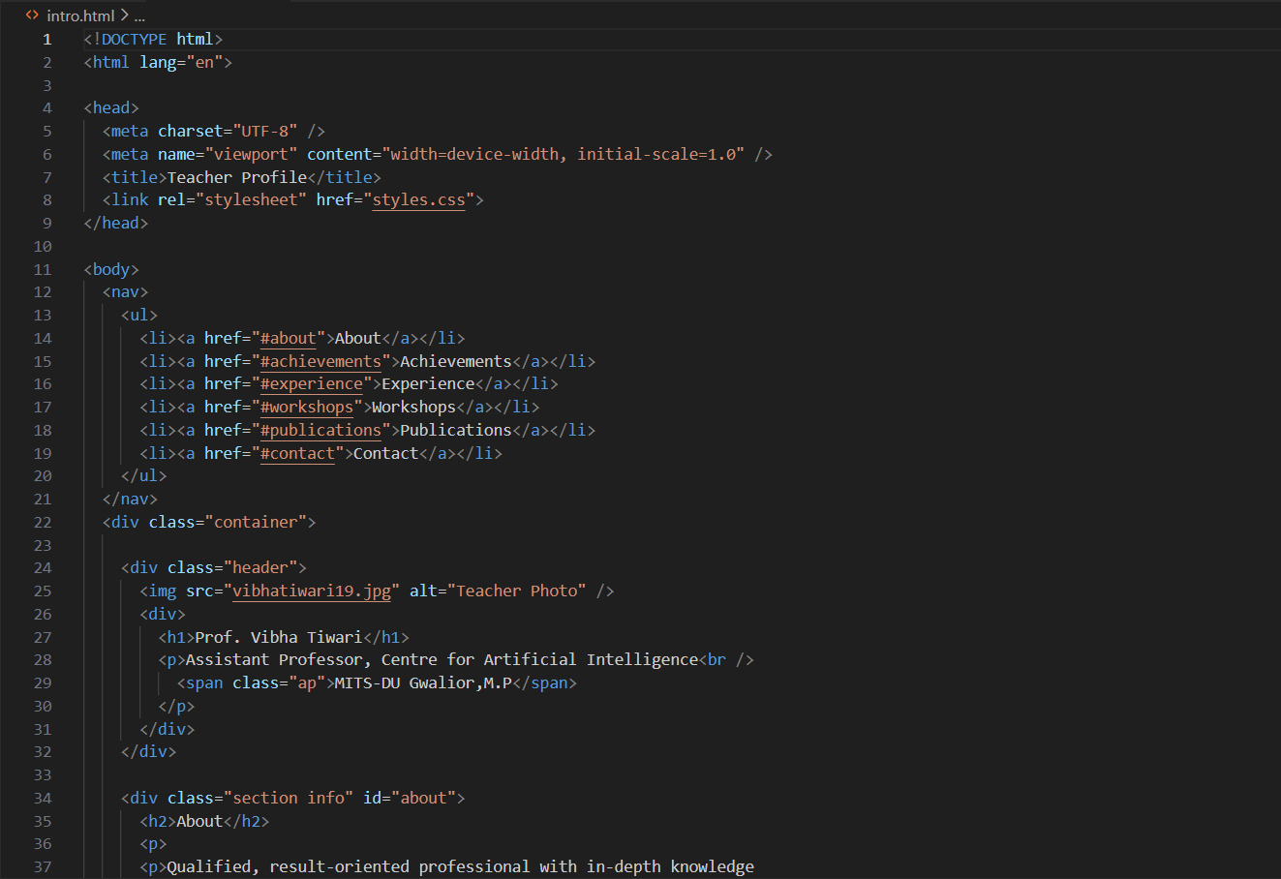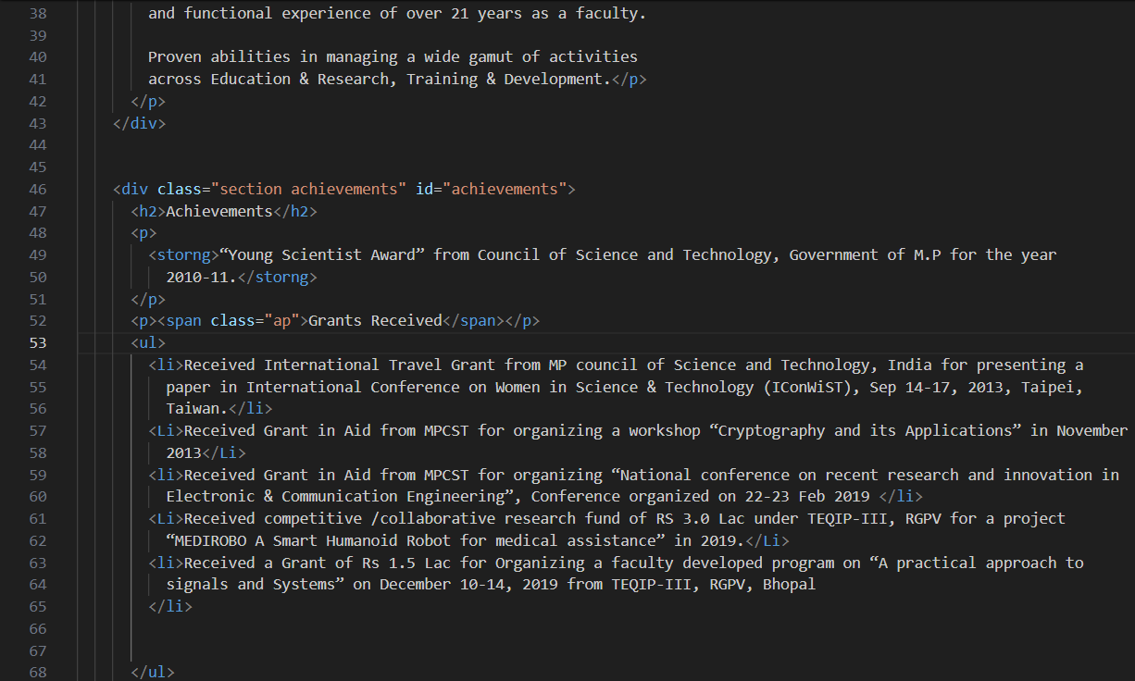
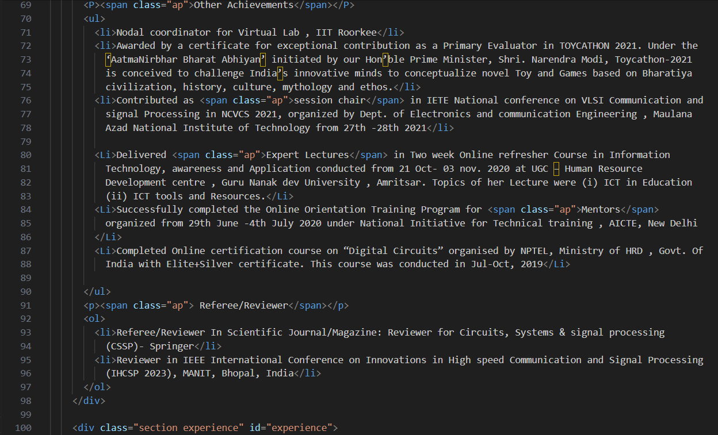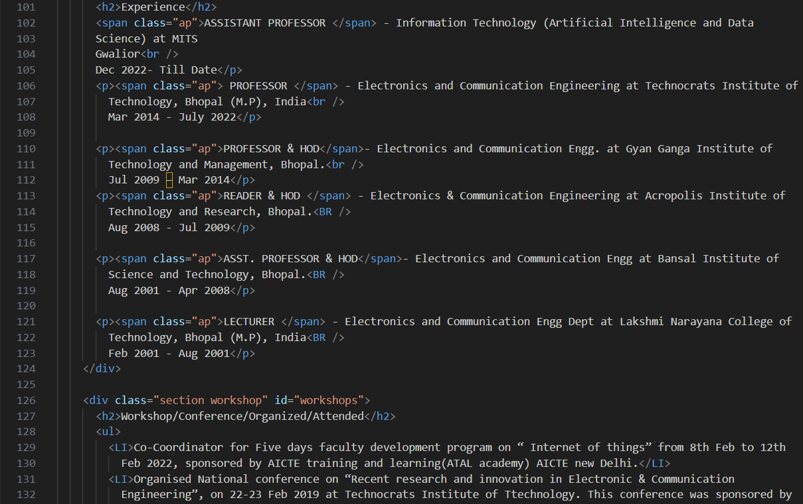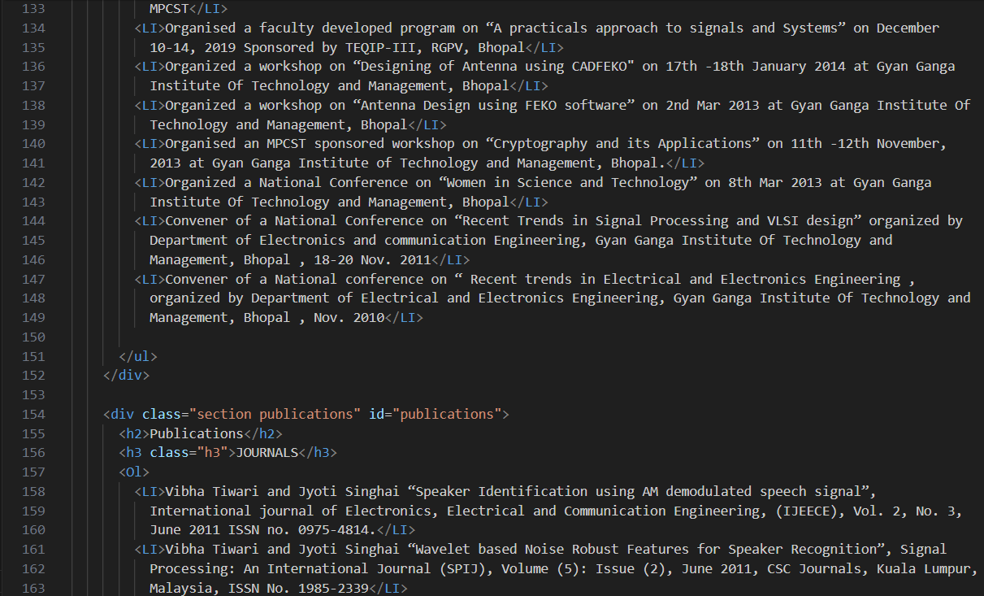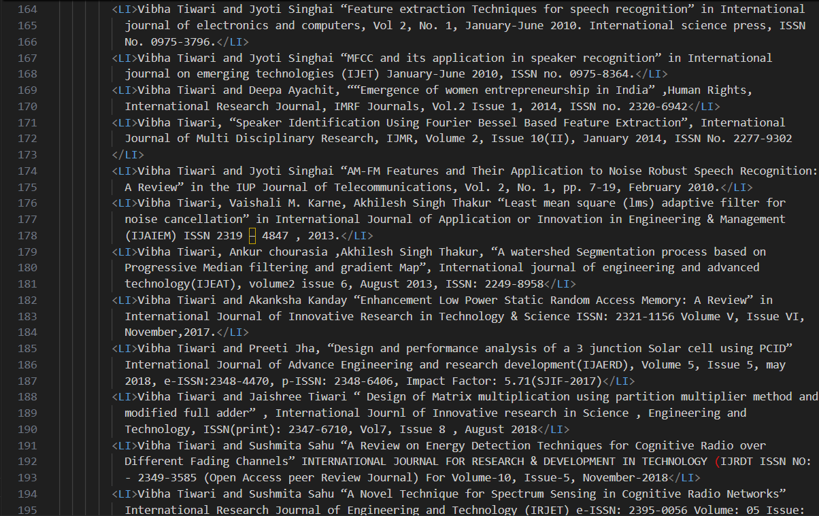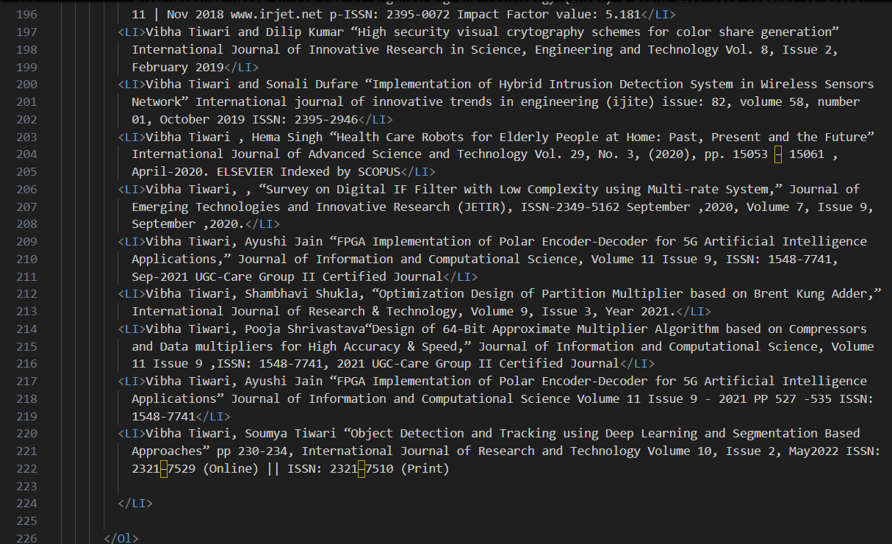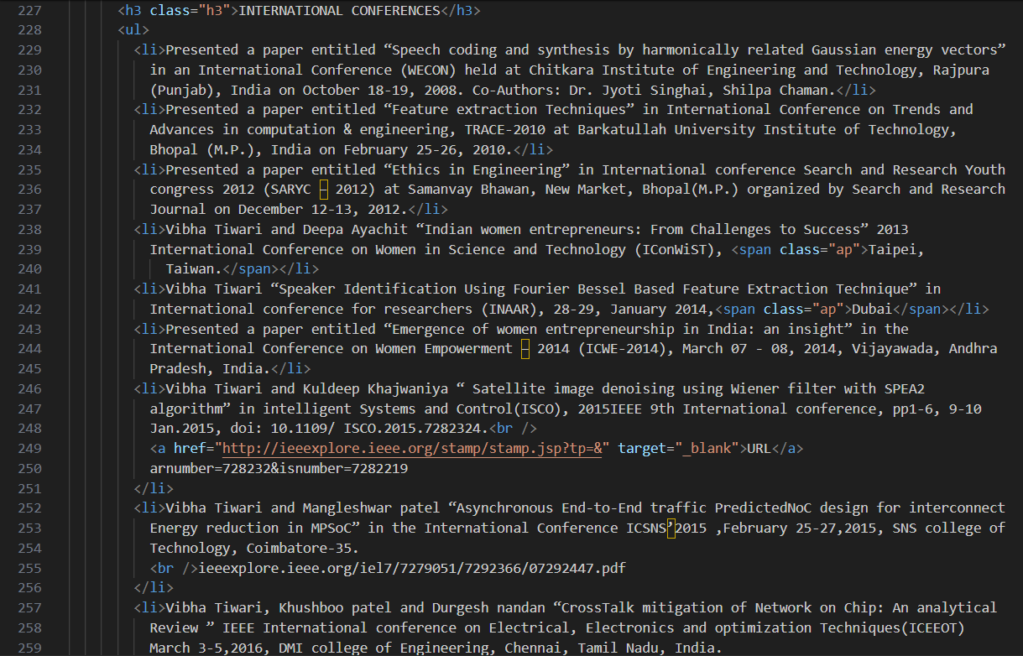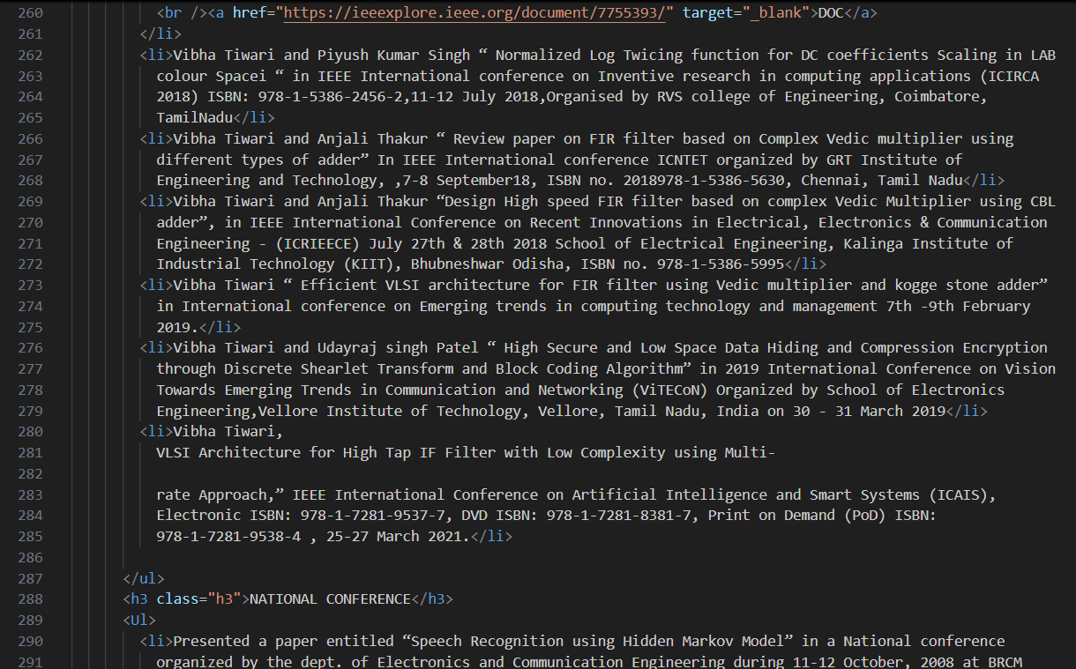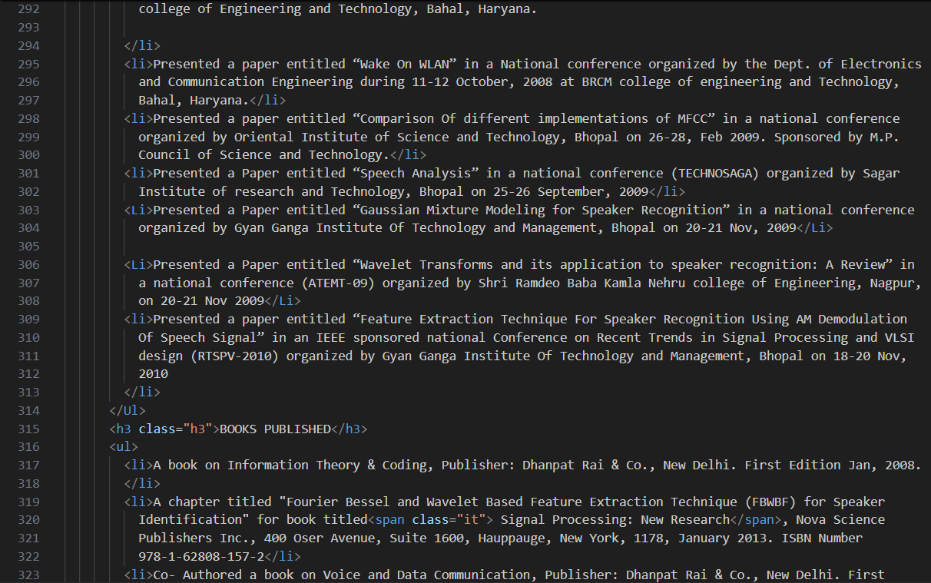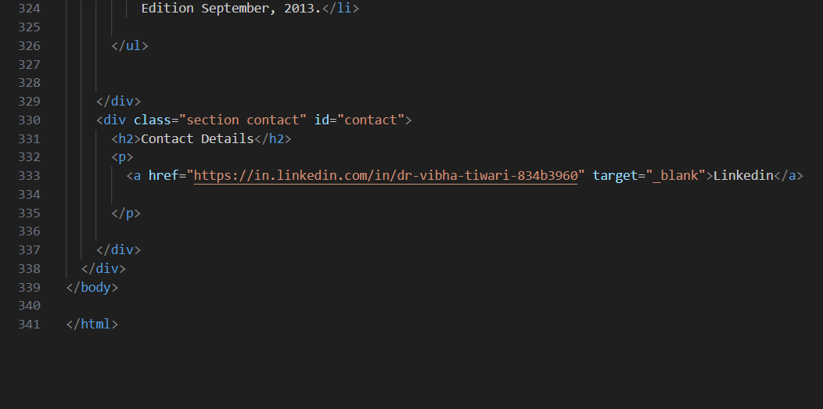

Chapter 5: Outcome

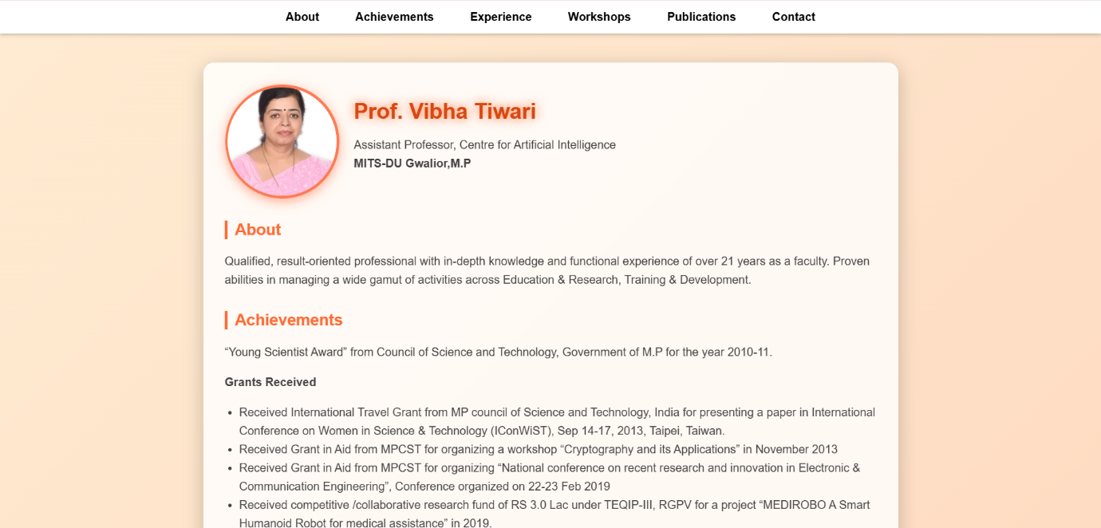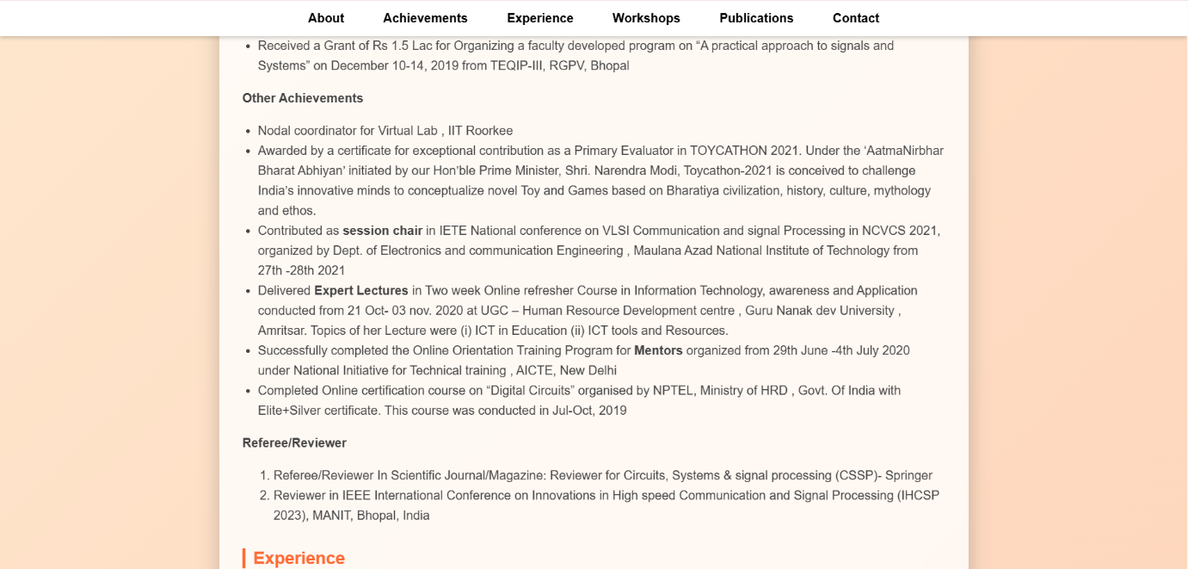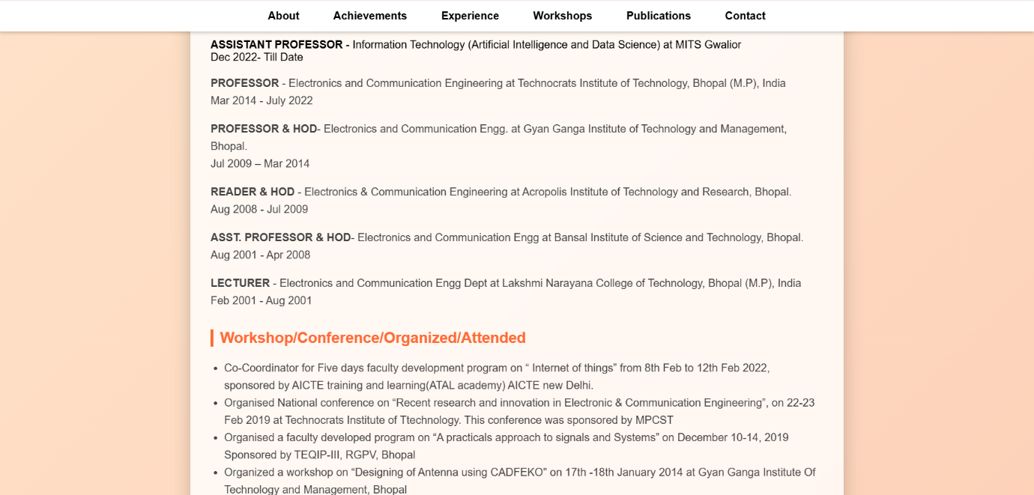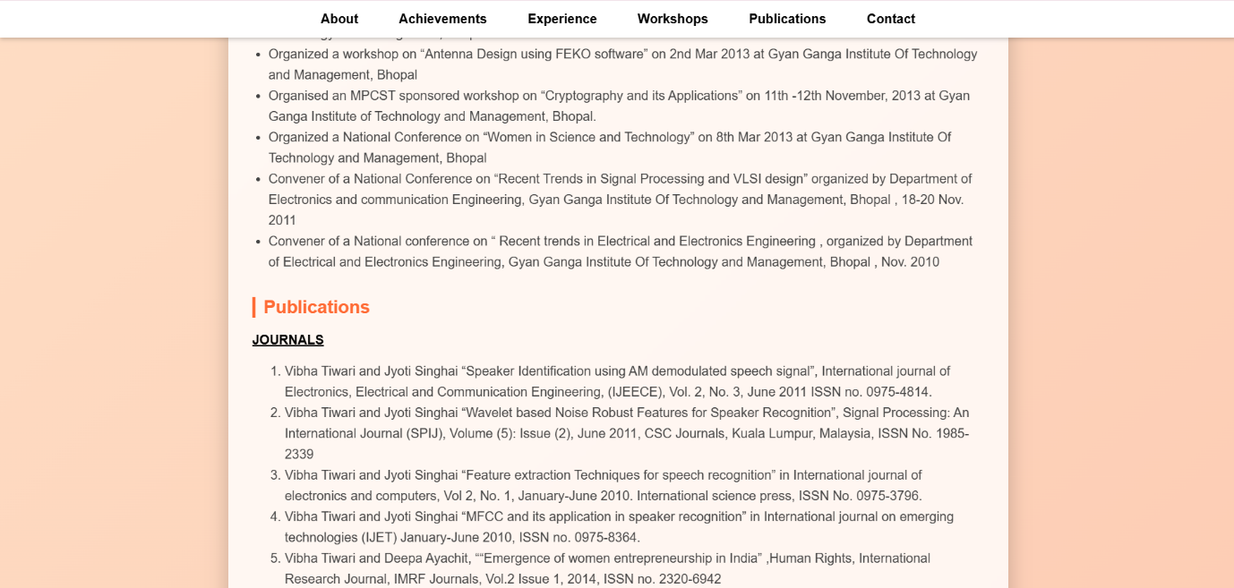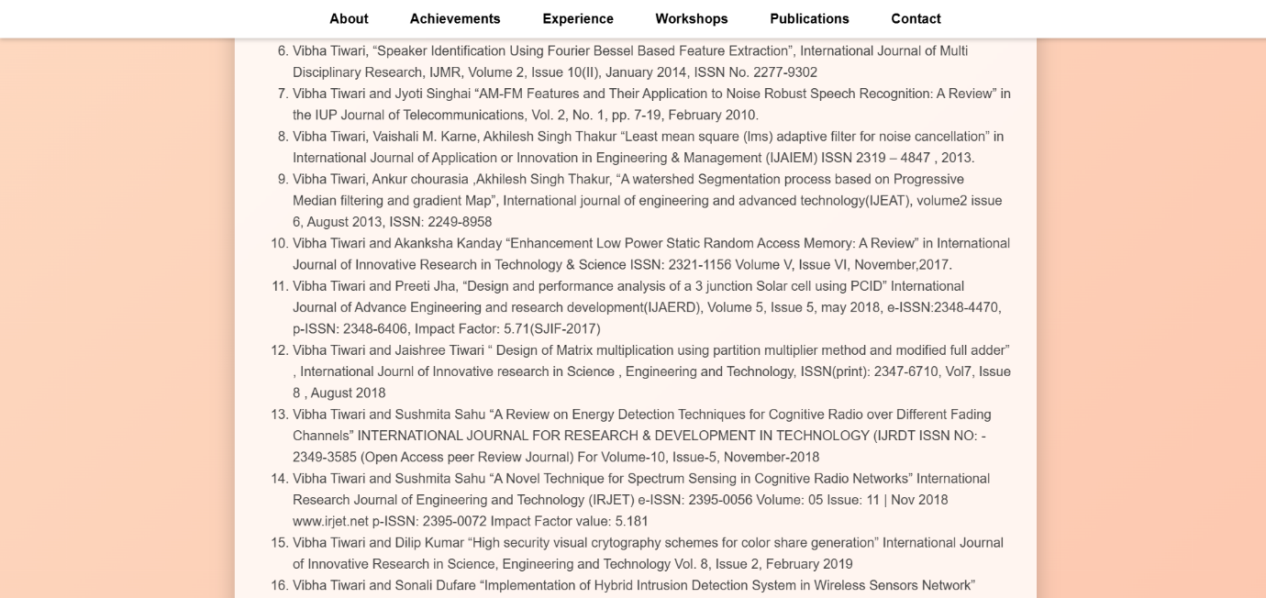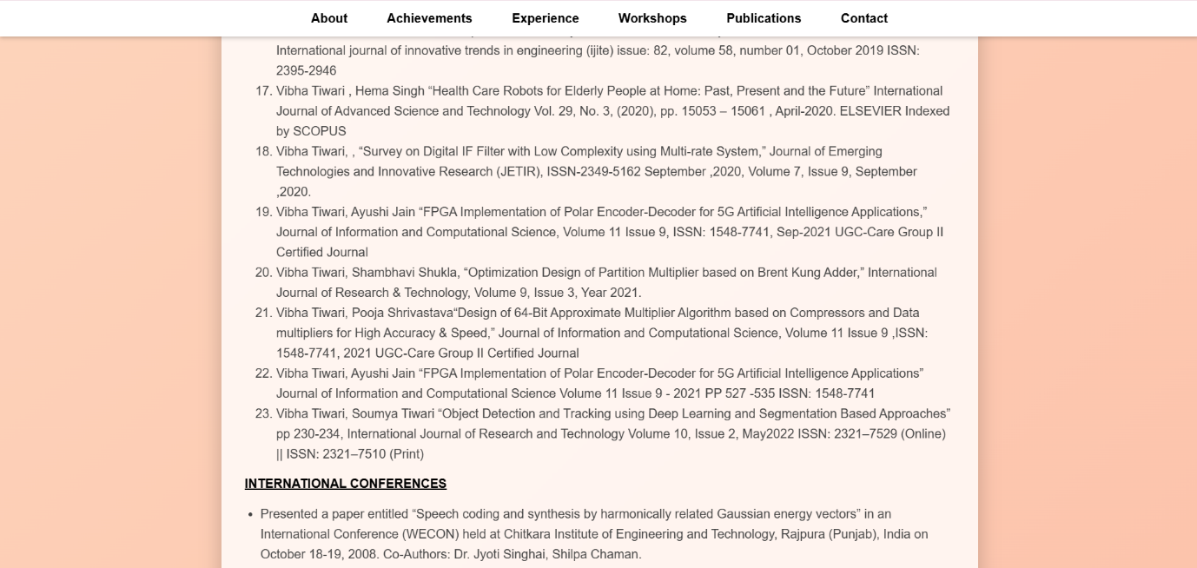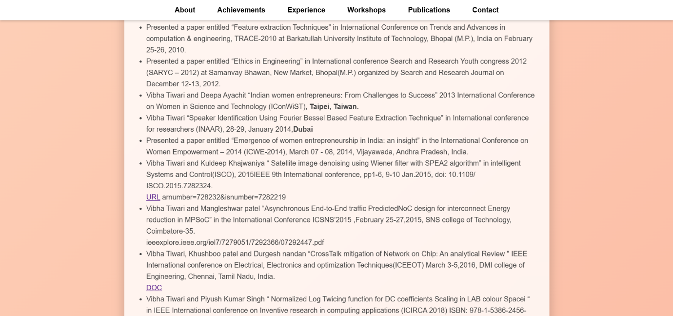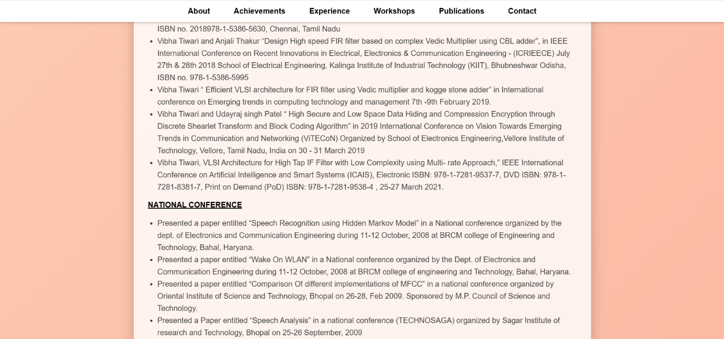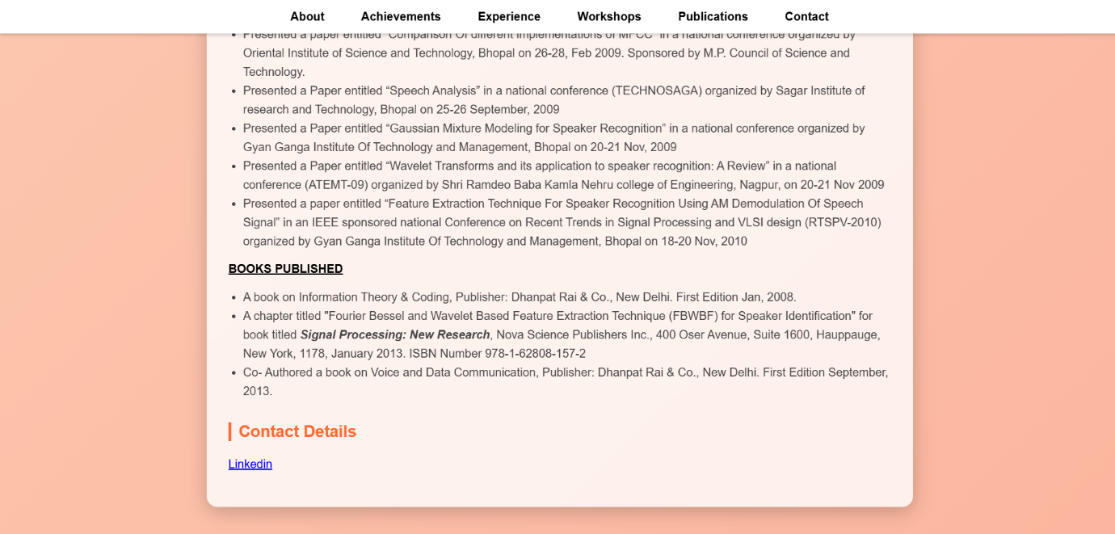

References

• W3Schools = HTML , CSS Theory.
• YouTube = Profile page design using HTML/CSS.

Turnitin Plagiarism & AI writing Report

Please Insert a Scanned Copy of the Front pages duly signed by the Candidate, and Supervisor,

